Course: SEN4016 – Multivariate Data Analysis
Name: Alihan Kalfa
İD:2200182

PROJECT REPORT: BREAST CANCER DIAGNOSIS ANALYSIS

1. Problem Definition and Dataset Description
Problem Definition: Breast cancer is one of the most common and serious health issues worldwide. Early and accurate diagnosis is critical for effective treatment. In this project, the main objective is to analyze the physical characteristics of cell nuclei to distinguish between Malignant (cancerous) and Benign (non-cancerous) tumors. By using multivariate statistical techniques, I aim to identify patterns in high-dimensional data and classify the diagnosis without human intervention.
Dataset Description: I used the "Breast Cancer Wisconsin (Diagnostic)" dataset from the UCI Machine Learning Repository.
- Samples: The dataset consists of 569 patients.
- Variables: It contains 32 variables in total. The target variable is Diagnosis (M or B). The input features include 30 numeric variables describing the cell nuclei, such as Radius, Texture, Perimeter, Area, and Smoothness.

2. Exploratory Data Analysis (EDA)
To understand the structure of the data before applying advanced techniques, I performed an exploratory analysis.
2.1. Diagnosis Distribution: First, I analyzed the balance of the dataset. As seen in Figure 1, the dataset contains more Benign (B) samples than Malignant (M) samples.
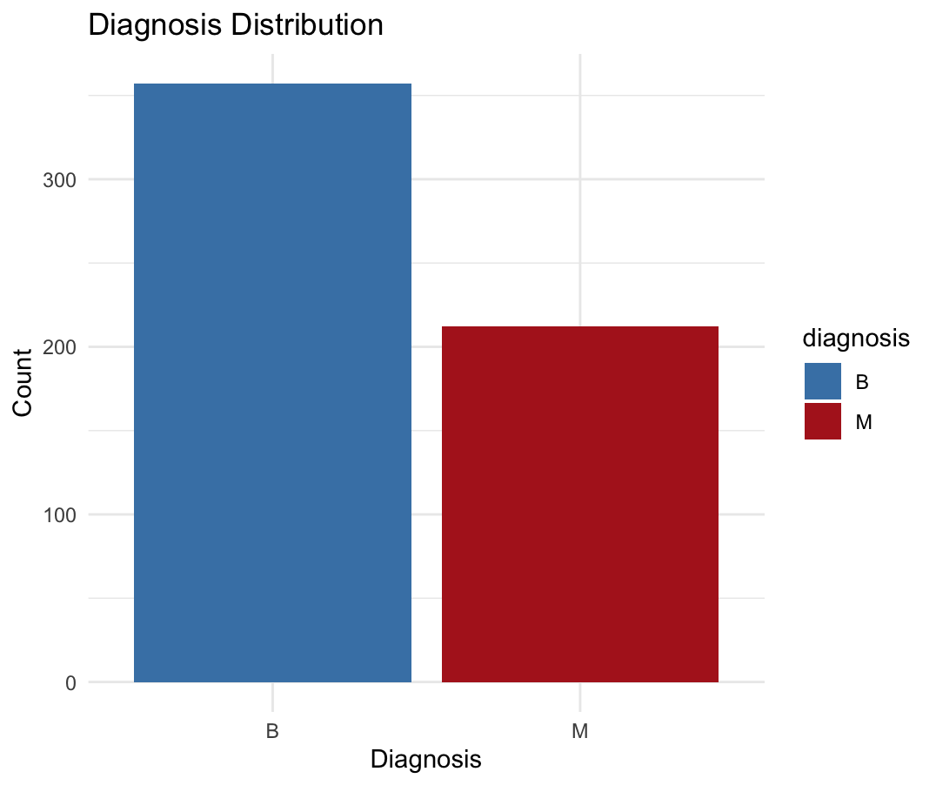
Figure 1 : Distribution of Diagnosis (Benign vs Malignant)

2.2. Correlation Analysis :Since the dataset has 30 numeric variables, it is important to check if they are correlated. I created a correlation matrix to visualize these relationships. As shown in Figure 2, there are strong positive correlations (dark blue areas) between variables like Radius, Perimeter, and Area. This indicates that Principal Component Analysis (PCA) is necessary to reduce the redundancy in the data.
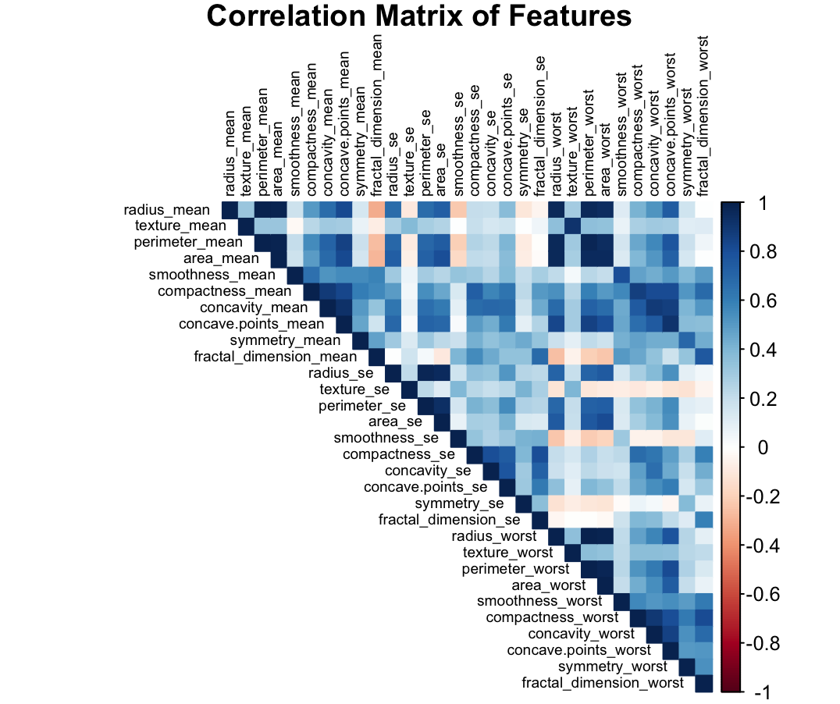
FİGURE 2: Correlation Matrix of the Features

3. Methodology
In this project, I applied two multivariate techniques as required:
- Principal Component Analysis (PCA): I selected this method because the dataset is high-dimensional (30 features) and has high multicollinearity (as seen in the correlation matrix). My goal with PCA was to reduce the dimensions and visualize if the cancer types separate naturally in a lower-dimensional space.
- K-Means Clustering: I used this unsupervised learning technique to group the patients into two clusters based only on their physical features, without using the actual diagnosis labels. This allows us to test if the data naturally organizes itself into "Cancer" and "Healthy" groups.

4. Interpretation of Results
4.1. PCA Results I applied PCA to the standardized data to interpret the factors. The result is visualized in Figure 3.
- What do factors represent ? The first principal component (Dim1) captures the most significant variance (44.3%) in the data, representing the overall size and shape irregularity of the cells. The second component (Dim2) explains 19% of the variance.
- Separation: The plot shows that Malignant (Red) and Benign (Blue) samples are highly distinct along these factors. This confirms that cell size and shape are strong indicators of cancer.
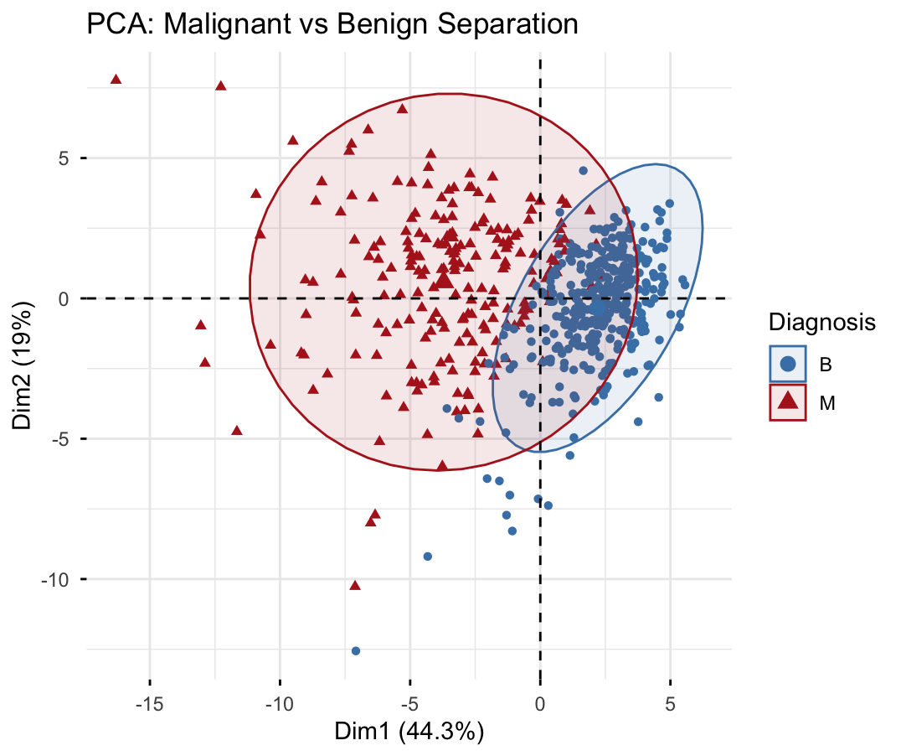
Figure 3: PCA Plot showing separation between Malignant and Benign samples

4.2. Clustering Results I applied the K-Means algorithm with centers. The resulting clusters are shown in Figure 4.
- Observation: The algorithm successfully identified two main groups (Blue and Yellow areas).
- Comparison: When we compare these clusters with the real diagnosis, we see a high overlap.
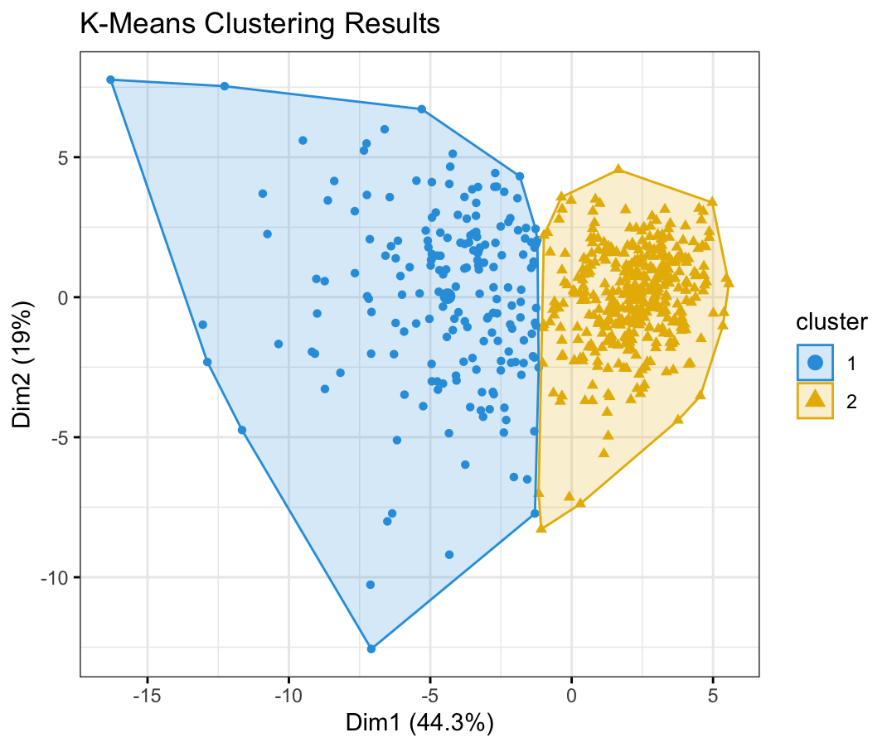
Figure 4: K-Means Clustering Results

4.3. Validation (Confusion Matrix): To measure the success of the clustering, I compared the computer-generated clusters with the real diagnosis labels. The confusion matrix is shown below:
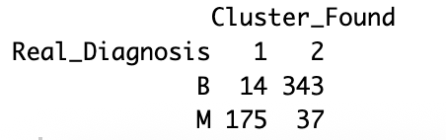
Table: Confusion Matrix (Real Diagnosis vs. Found Clusters)

Interpretation: The table shows that the algorithm correctly classified the majority of Benign (B) and Malignant (M) cases. The error rate is low, which demonstrates the effectiveness of the analysis.

5. Conclusion
In this project, I analyzed the Breast Cancer dataset using PCA and Cluster Analysis.
- PCA showed that high-dimensional data can be reduced to 2 dimensions while keeping the most important information.
- Clustering proved that it is possible to identify cancer groups with high accuracy using only physical features. Overall, the project demonstrates that multivariate statistical techniques are powerful tools for medical diagnosis and decision-making.

